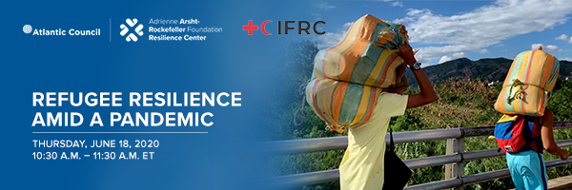
Climate change, disasters and conflict are major drivers behind the greatest levels of migration in human history. 70 million people have been forcibly displaced, of which nearly 30 million people qualify as refugees.
COVID-19, in its rapid proliferation, has introduced added layers of risk to those least prepared and equipped to cope. In advance of World Refugee Day (June 20), the Adrienne Arsht-Rockefeller Foundation Resilience Center and the International Federation of Red Cross and Red Crescent Societies cordially invite you to join a dialogue among experts to recognize the resilience of refugees, the increasing risks they face and solutions for reducing their vulnerabilities.
Under the United Nations 1951 Convention and 1967 Protocols, refugees are entitled to globally agreed upon rights and services, yet current conditions that have led to strained healthcare systems, economic collapse, environmental degradation and social upheaval, leading many countries to stymie migration and curtail even the most basic refugee services for those within their borders. The result is a growing number of persons impacted by COVID-related border closures and vulnerable to both the health and socio-economic impacts of the pandemic.
Despite the challenges, solutions and good practices that point toward the possibility of a future world where refugees can safely call new places home and contribute to the health, well-being and solidarity of the communities that embrace them. As examples, private sector efforts to train and employ refugees are proliferating. Social media and other campaign platforms are countering xenophobia to change the narrative around migration, emphasizing all the benefits to society that come from diversity and inclusion.
The Adrienne Arsht-Rockefeller Foundation Resilience Center, in partnership with the International Federation of Red Cross and Red Crescent Societies, host this virtual event in honor of World Refugee Day to call attention to the risks refugees now face and share initiatives that are creating an enabling environment for their safety, well-being, prosperity and societal contribution.
This event is part of our Climate & Migration Dialogue Series, which promotes a positive narrative around migrants and refugees as contributors to culture and society. These discussions will feature top experts via virtual and in-person events and podcasts, sharing new research and firsthand accounts of refugee and migrant experiences. We will also explore cutting-edge initiatives to combat xenophobia, improve perceptions around migration and build greater social inclusion within host communities. This effort also aims to cultivate a growing community of stakeholders who can inform thinking and advance collective problem-solving in order to build global resilience to migration and climate change.

